Shoreline Hazards and Habitat Loss Report
What does the future look like when our natural coastal protection systems begin to weaken? Coastal habitats such as marshes, oyster reefs, dunes, forests, and underwater grasses play a critical role where land meets water by supporting ecosystems and protecting nearby communities. These habitats are constantly changing due to natural processes and human impacts, making them increasingly vulnerable over time. At the same time, coastal hazards including erosion, low elevation, sea level rise, wave action, storm surges, and geomorphological changes continue to threaten shorelines. As these hazards intensify and habitats decline, the ability of coastal environments to protect both wildlife and people may become significantly weaker.
We have seen through real world examples about how coastal habitats can protect communities, but what areas need the most protection? Do certain habitats provide protection to certain areas? How does the future of these habitats look? My goal is to tell a story about the benefits and risks of our coastal habitats in Maryland. To answer my questions, I will be visualizing my data using Google Colab. With the help of other tools such as R studio and Tableau, I am able to get a good idea of how my data looks before refining visualizations for presenting.
My data comes from the and through the Maryland Coastal Resiliency Assessment, which was created to identify priority restoration and protection areas for communities at risk from coastal hazards. The main dataset, the Shoreline Hazard Index, includes information on both coastal habitats and physical hazards, containing six hazard variables, five habitat types, and location-based descriptive data. I also incorporated the Marsh Protection Potential Index into my analysis to explore habitat conditions, resilience, and community risk in greater depth.
I began my data cleaning by loading and inspecting my main dataset to understand its structure, including the number of rows, columns, and variable types. I then imported a second dataset from a JSON file, converted it into a dataframe, and merged it with my original dataset using a variable called OBJECTID. Next, I converted habitat presence variables from “Yes/No” into binary 0/1 values and mapped categorical hazard levels like “Low” and “High” into numeric scores 0–4 for easier analysis. I also made sure hazard variables were treated as ordered categories. Finally, I handled missing data by identifying columns with null values. Because the Shoreline_Priority_Area column had too many missing values, I removed it to avoid losing a large portion of my data. For the remaining columns with missing values, I dropped rows containing nulls, resulting in a clean final dataset reduced from 14,328 to 11,280 rows with no missing values.
To begin my analysis, I wanted to visualize what the future of our habitats would look like. To do this, I used the variable PercentRemaining2100. As you can see, the result is very much skewed to the right, meaning that a large portion of areas are expected to retain a very low percentage of their habitats by 2100. The peak on the left side of the graph displays that this large amount of areas will reach a significantly low percent remaining. However, from the tail end of the graph, we can see that some areas are more resilient. It is important to understand what factors play into the loss and resilience of habitats.

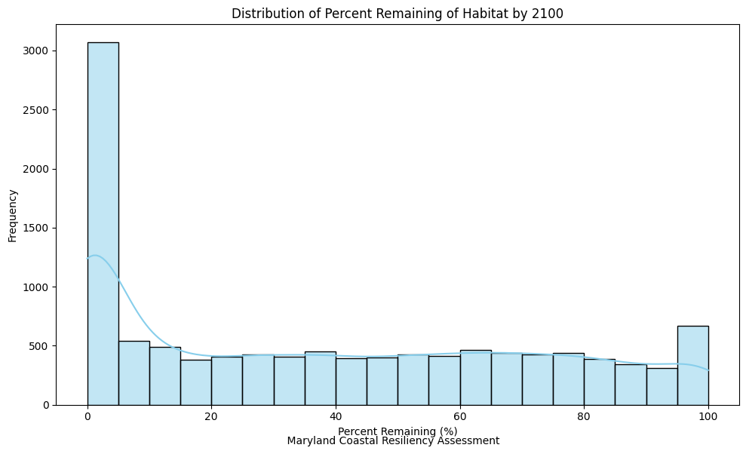
Although we know that habitats are diminishing significantly, I wanted to visualize how habitat loss varies across habitat types. Clearly, some habitats are being disrupted more than others. For example, forests and marshes are set to lose over 60% of their area on average. On the other hand, underwater grass, oyster reefs, and dunes are to lose less than 60 percent of their area by 2100 on average. Though the difference is small, it is important to take it into account when applying strategies for prevention of loss.
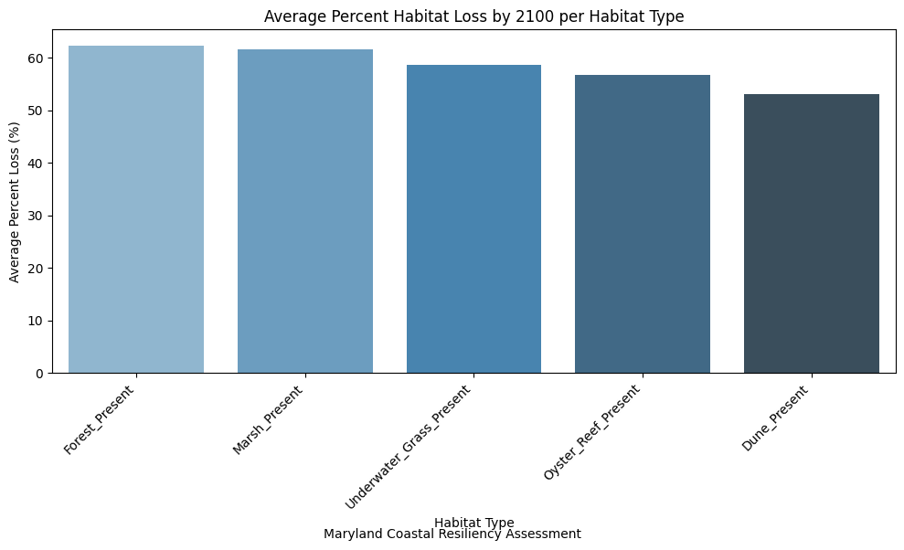

I thought that a bar chart comparing the habitat loss across counties could help to zoom in on what counties needed the most help. The range between averages is something to take into account with Caroline county having an average 74.7 percent loss of habitats and Worcester having only a 52.8 percent loss of habitats.

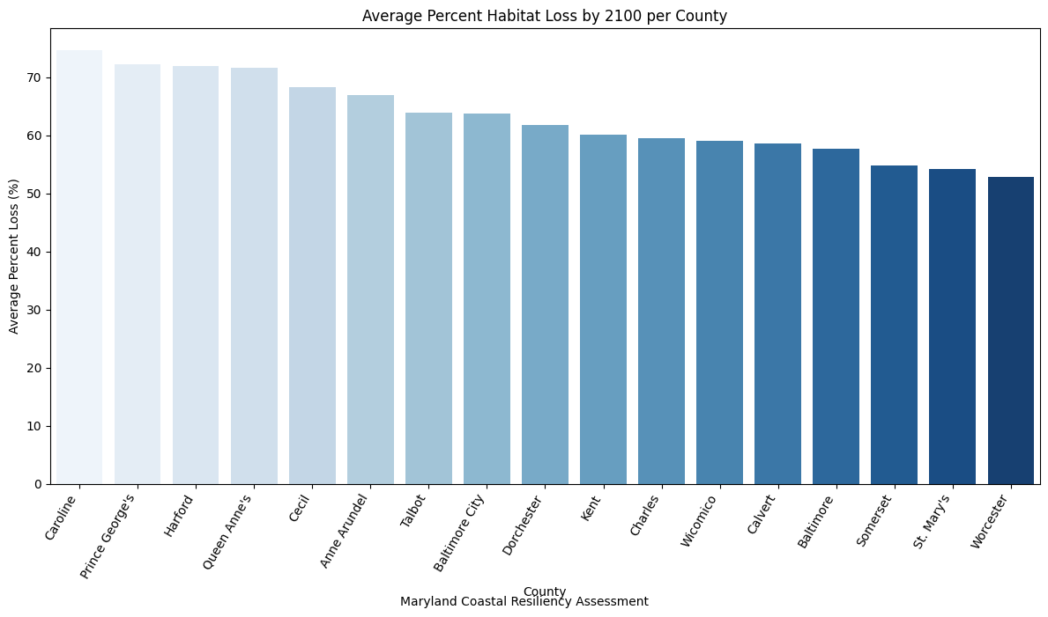

Why should we even care about protecting our coastal habitats? Clearly shown in the boxplot, we can see that when taking habitats into account, hazards are lower on average than without taking habitats into account. It is important to keep in mind that hazards in my data range from 0-4, or very low-very high. These hazards include geomorphology, elevation, sea level rising, waves, storm surges, and erosion.
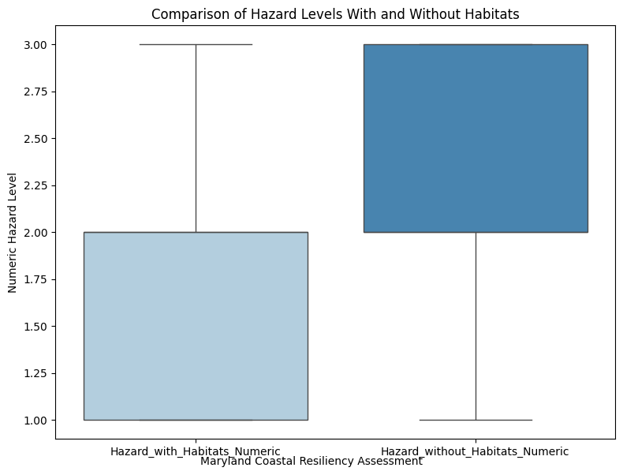
We can also see that the more habitat-diverse an area is, the more it reduces hazard risk. Having two or three different types of habitats protects against hazards more than only having one type. However, this is dangerous when we take into account the fact that these habitats are diminishing. The chance of having two or three strong habitats would be even weaker in the future.
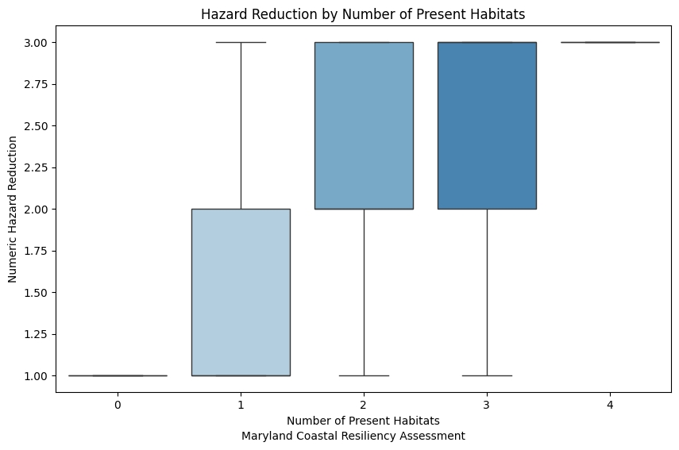
We can also visualize the average protection by habitat type for each county. I removed dunes and oyster reefs from this graph, as there was much missing data. From a previous example, we saw that Caroline county was at risk for a large amount of habitat loss. From this graph, we can see that Caroline county gets its protection against hazards from marshes and forests, which we know are depleting more than other coastal habitat types. Caroline county among others could be a focal point for targeting habitat protection.
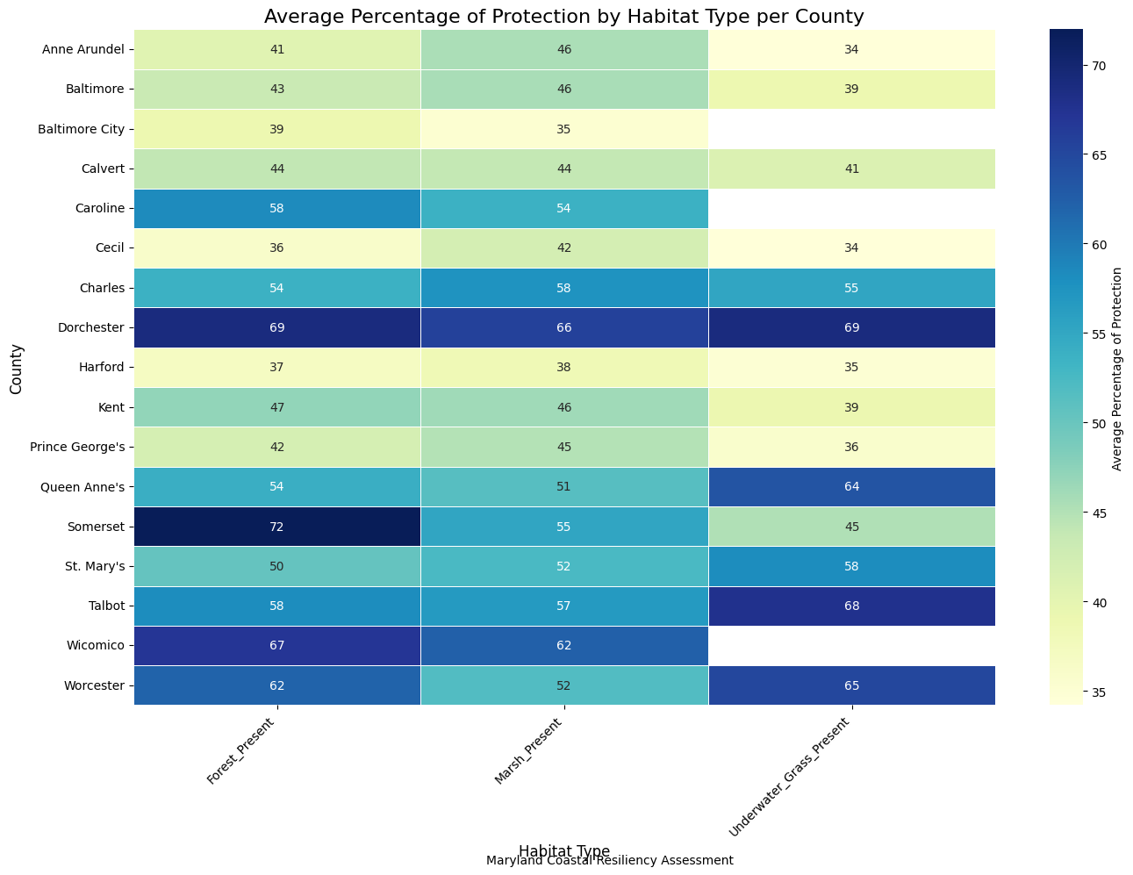
I loaded and prepared my dataset, then selected PercentRemaining2100 as the target and PercentBufferRemain as the predictor. I split the data into training (80%) and testing sets (20%), scaled the predictor, and fit an OLS linear regression model. Finally, I evaluated the model using R² and RMSE and visualized the relationship with a scatterplot and regression line. I got an R² value of 0.081and an RMSE of 31.7 finding a weak but statistically significant relationship. This means that the amount of buffer remaining of a habitat does likely play a part into the integrity of the habitat. Buffers refer to the surrounding undeveloped areas that protect habitats from human impact and environmental stress, helping reduce disturbance and support long-term ecosystem stability.
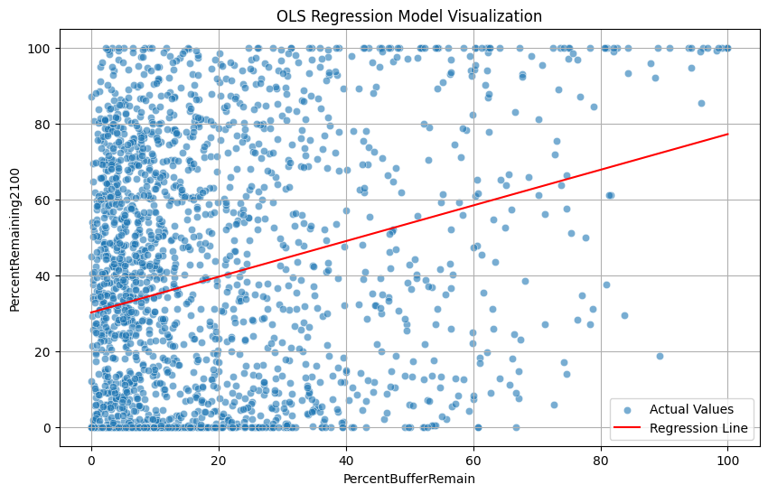
My analysis showed that coastal habitats play an important role in reducing hazard risk, as areas with a greater amount or diversity of habitats generally experience lower exposure to coastal hazards. However, habitat loss is not occurring evenly, with some ecosystems and counties being affected more severely than others, which highlights differences in vulnerability across Maryland’s coastline. The results also suggest that habitat diversity strengthens natural coastal protection, though this protection may weaken as habitats continue to decline over time. In addition, buffer preservation showed a positive but relatively weak relationship with long-term habitat survival, indicating that buffers still contribute to resilience. Overall, these findings emphasize the importance of protecting and restoring coastal habitats and their surrounding buffers to help maintain future coastal resilience.
What was especially challenging in this project was trying to create a story. At first, I had a bunch of graphs that I did not know how to connect or how I could apply it to the real world. What was rewarding in the end after facing obstacles was finding information I did not think I would find. I would have never guessed that so much habitat loss would occur in less than 100 years. This started coming together when I began exploring variables that I thought would be too challenging to use. However, these variables were key to uncovering information. In the future, I will not overlook variables just because I don’t understand them. This project could be expanded by exploring how communities would be impacted if a natural hazard were to show up. The social vulnerability index describes how much help a community would need after flooding. Comparing this with community flood risks, we can see if communities that would need more help actually are at higher risks.
I would like to thank some people that supported my understanding of the tools and concepts that I used in this project. This includes Professor Alraee, Professor Perine, Professor Park, the Early College Data Science Cohort, the Montgomery County Government, the DataMontgomery team, and my Data 205 Classmates.

